1.Write a python programme to solve 8 puzzle problem

Aim:
Write a program to solve 8 puzzle problem.

Objectives:The 8-puzzle problem is a game with 8 numbered tiles and 1 blank space (0) arranged in a 3 × 3 grid. The objective is to move the blank space up, down, left, or right to arrange the tiles in the correct order and reach the goal state.

Algorithm:
1. Start.
2. Define the initial puzzle state.
3. Define the goal state.
4. Compare the current state with the goal state.
5. If they are the same, display "Puzzle Solved".
6. Otherwise, move the blank tile (0) in a valid direction.
7. Repeat steps 4–6 until the goal state is reached.
8. Stop.

Flowchart:

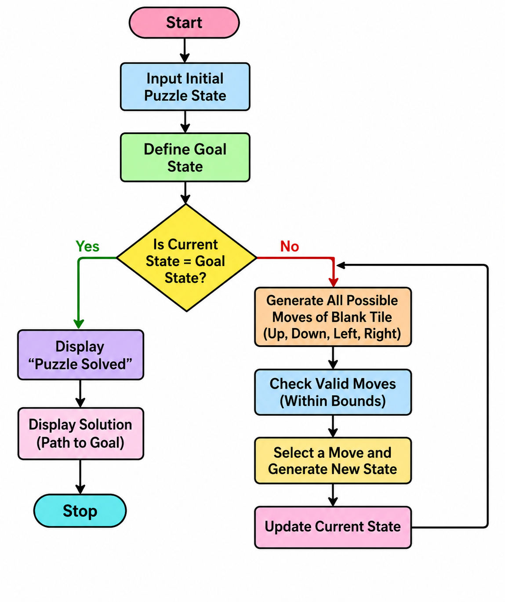
Source Code:
from collections import deque

goal = ((1, 2, 3),
(4, 5, 6),
(7, 8, 0))

start = ((1, 2, 3),
(4, 0, 6),
(7, 5, 8))

def get_next_states(state):
states = []
for i in range(3):
for j in range(3):
if state[i][j] == 0:
x, y = i, j

moves = [(-1,0), (1,0), (0,-1), (0,1)]

for dx, dy in moves:
nx, ny = x + dx, y + dy
if 0 <= nx < 3 and 0 <= ny < 3:
new = [list(row) for row in state]
new[x][y], new[nx][ny] = new[nx][ny], new[x][y]
states.append(tuple(tuple(row) for row in new))

return states

def solve(start):
queue = deque([start])
visited = set()

while queue:
state = queue.popleft()

if state == goal:
print("Puzzle Solved!")
for row in state:
print(row)
return

visited.add(state)

for next_state in get_next_states(state):
if next_state not in visited:
queue.append(next_state)

print("No Solution Found")

solve(start)
Result:
The program was executed successfully. The blank tile (0) was moved correctly, and the initial puzzle state was transformed into the goal state. Hence, the 8-puzzle problem was solved successfully.

Output:

